Authors Biography

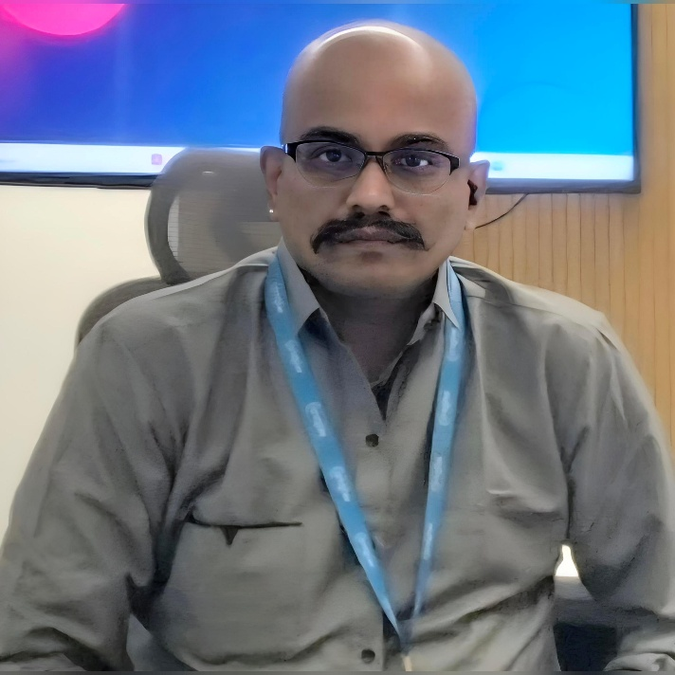
Dr. Magesh Kasthuri is a Distinguished Member of Technical Staff (DMTS Master) and Chief Architect (Cloud) / Chief Technologist at Wipro Limited, Bengaluru, India. With over 26 years of IT industry experience — including 22+ years at Wipro — he is recognised as one of the Top 25 Technologists in the organisation and has served as Global Charter Lead for the entire DMTS community since 2025. He holds a Doctor of Philosophy (Ph.D.) in Deep Learning and Genetic Algorithms and has been granted patents in the US and European Patent Offices across Cloud, AI/ML, Blockchain, Big Data, and DevOps. His professional interests span Agentic AI, Generative AI, LLMs, Metaverse, NFT, Big Data Analytics, Cognitive Computing, and Cloud Computing. A prolific author and thought leader, Dr. Kasthuri has published more than 200 articles and papers across prestigious international platforms including CIO.com, CXOTech Magazine, Architecture & Governance Magazine, Open Source For You, and the Cutter Business IT Journal. He has authored over 1,000 short technical articles on LinkedIn under the tag #shorticle and published books in seven languages. Client work experience spans Japan, the United States, and Switzerland. He is an IEEE Senior Member, ACM Senior Member, and holds 13+ professional certifications across Microsoft, AWS, Google, Oracle, IBM, FinOps Foundation, and Blockchain Council.
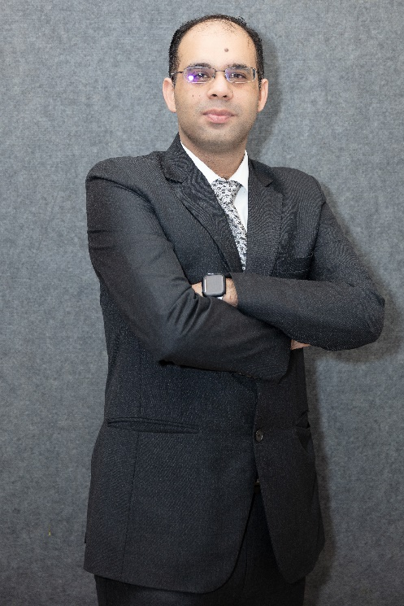
Dr. Anand Nayyar received Ph.D (Computer Science) from Desh Bhagat University in 2017 in the area of Wireless Sensor Networks, Swarm Intelligence and Network Simulation. He is currently working in School of Computer Science and Artificial Intelligence (SCA)-Duy Tan University, Da Nang, Vietnam as Professor, Scientist, Vice-Chairman (Research) and Director- IoT and Intelligent Systems Lab. A Certified Professional with 280+ Professional certifications from CISCO, Microsoft, CompTIA, Amazon, Alibaba Cloud, Oracle, Google, Salesforce, Tableau, FinOps, Beingcert, EXIN, GAQM, Cyberoam and many more. Published more than 300+ Research Papers in various High-Quality ISI-SCI/SCIE/SSCI Impact Factor- Q1, Q2, Q3, Q4 Journals cum Scopus/ESCI indexed Journals, 80+ Papers in International Conferences indexed with Springer, IEEE and ACM Digital Library, 60+ Book Chapters in various SCOPUS/WEB OF SCIENCE Indexed Books with Springer, CRC Press, Wiley, IET, Elsevier with Citations: (Google Scholar): 25000+, H-Index: 80 and I-Index: 330; (Scopus): 14000+; H-index: 62. Member of more than 60+ Associations as Senior and Life Member like: IEEE (Senior Member) and ACM (Senior Member). He has authored/co-authored cum Edited 80+ Books of Computer Science. Associated with more than 600+ International Conferences as Programme Committee/Chair/Advisory Board/Review Board member. He has completed 1 Grassroot and 1 ASEAN Project. He has 18 Australian Patents, 16 German Patents, 4 Japanese Patents, 46 Indian Design cum Utility Patents, 13 UK Patents, 1 USA Patent, 3 Indian Copyrights and 2 Canadian Copyrights to his credit in the area of Wireless Communications, Artificial Intelligence, Cloud Computing, IoT, Healthcare, Drones, Robotics and Image Processing. He has guided more than 200+ Undergraduate Students (B.S. Degree), 30 MCA, 7 M.S. Students and completed 1 Ph.D Student and currently 3 Ph.D Scholars and 3 PostDoc Candidates are working under him. He has completed 4 Research Grants Projects including 1 ASEAN and 1 Glocal 30 Project and 1 Grassroot Project in DTU. Awarded 58 Awards for Teaching and Research—Young Scientist, Best Scientist, Best Senior Scientist, Asia Top 50 Academicians and Researchers, Young Researcher Award, Outstanding Researcher Award, Excellence in Teaching, Best Senior Scientist Award, DTU Best Professor and Researcher Award- 2019, 2020-2021, 2022, 2022-2023, 2023-2024, 2024-2025, Distinguished Scientist Award by National University of Singapore, Obada Prize 2023, Lifetime Achievement Award 2023, 2024; Asian Admirable Achievers 2024; Distinguished Academic Leader 2024, Lifetime Achievement Award 2024 and many more.
He is listed in Top 2% Scientists as per Stanford University (2020, 2021, 2022, 2023, 2024, 2025), Ad Index (Rank No:1 Duy Tan University, Rank No:2 Computer Science in Viet Nam) and Listed on Research.com (Top Scientist of Computer Science in Viet Nam- National Ranking: 2; D-Index: 64; World Ranking: 2555).
He is acting as Associate Editor for Computer Communications (Elsevier), International Journal of Sensor Networks (IJSNET) (Inderscience), Tech Science Press- IASC, Human Centric Computing and Information Sciences (HCIS), IEEE Transactions on Artificial Intelligence (IEEE TAI), Indonesian Journal of Electrical Engineering and Computer Science, IJISP, IJDST, IJCINI, IJGC, IJSIR, IJBDCN, IJSI, IJIES, IJKSS. He has reviewed more than 5700+ Articles for diverse Web of Science and Scopus Indexed Journals. He is currently researching in the area of Wireless Sensor Networks, Internet of Things, Swarm Intelligence, Cloud Computing, Artificial Intelligence, Drones, Blockchain, Cyber Security, Healthcare Informatics, Big Data and Wireless Communications.

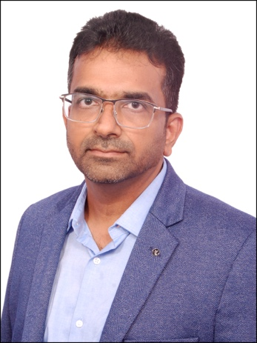

Dr. Gopichand Agnihotram, Ph.D. is a distinguished Artificial Intelligence, Machine Learning, and Generative AI leader with more than 18 years of experience in research, innovation, consulting, and enterprise-scale AI transformation. Currently serving as Director – AI & ML in the Wipro CTO Office, he leads strategic AI initiatives spanning Generative AI, Agentic AI, Large Language Models (LLMs), Small Language Models (SLMs), Retrieval-Augmented Generation (RAG), Reinforcement Learning, Computer Vision, NLP, Multimodal AI, and Intelligent Automation. A Ph.D. in Statistics from IIT Bombay, he has successfully driven AI innovation across healthcare, BFSI, retail, telecom, manufacturing, automotive, energy, and industrial sectors, delivering AI-powered platforms and solutions to more than 300 enterprise customers globally. His leadership extends beyond technology development to mentoring researchers, data scientists, and postgraduate students while shaping enterprise AI strategy and innovation roadmaps.
A prolific inventor and researcher, Dr. Agnihotram has built one of the strongest intellectual property portfolios in enterprise AI, with 24 granted USPTO patents, over 10 additional patent applications under review, 44+ peer-reviewed international journal and conference publications, multiple industry white papers, and an authored book on reliability engineering. His research and patents span Generative AI, Agentic AI, multimodal reasoning, AR/VR systems, computer vision, intelligent document processing, contextual search, autonomous assistance systems, predictive analytics, reinforcement learning, industrial diagnostics, recommendation systems, and enterprise knowledge automation. His recent work has focused on advanced RAG architectures, precision and recall optimization in retrieval systems, multimodal document intelligence, AI-driven governance and risk management, brain-computer interfaces, digital twins, intelligent manufacturing, and domain-specific AI platforms. Collectively, his publications have attracted more than 200 scholarly citations, reflecting the impact of his contributions across academia and industry and establishing him as a recognized thought leader in applied AI and enterprise innovation.
Throughout his career, Dr. Agnihotram has led the development of transformative AI solutions including multimodal RAG platforms, recruitment intelligence systems, enterprise document automation, fraud and deepfake detection frameworks, predictive maintenance solutions, intelligent retail analytics, autonomous AR/VR assistance systems, and next-generation decision intelligence platforms. His innovations have generated significant business value through AI-led transformation, consulting, customer innovation, and intellectual property monetization. His achievements have been recognized through numerous accolades, including the CII AI Award 2025 for Best Innovative Solution, multiple Wipro Excellence and Delivery Awards, the Best Paper Award at ICRTES 2020, the Wipro Exemplar Award, and prestigious Government of India fellowships for Master's and Doctoral research. Widely regarded as a pioneer in enterprise AI, Generative AI, and Agentic AI systems, he continues to advance the state of the art through groundbreaking research, patented innovations, industry leadership, and mentorship of future generations of AI practitioners and researchers.

